1. Install Software

a- Installation of Android Studio:

Steps to install Android studio are given below:

Step-1:

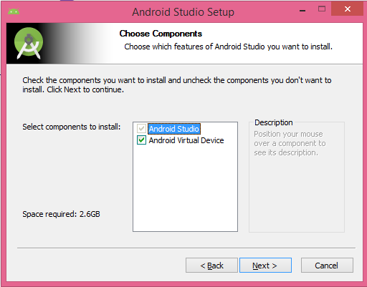

Step-2:

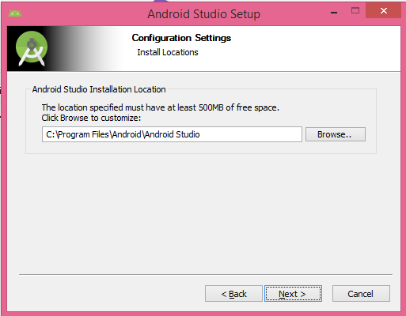

Step-3:

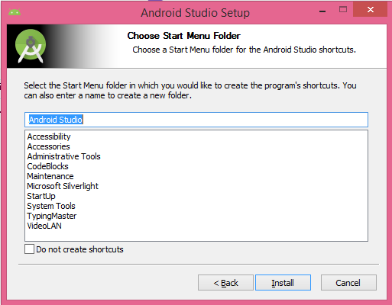

Step-4:

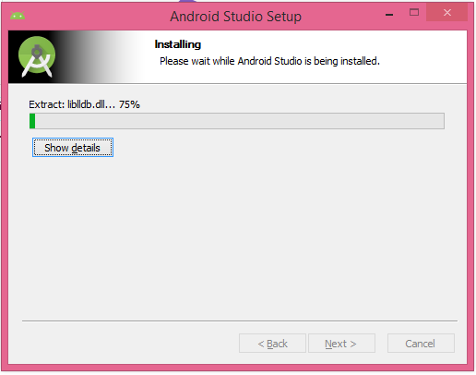

Step-5:

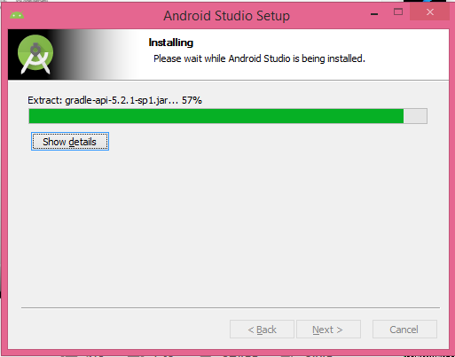

Step-6:

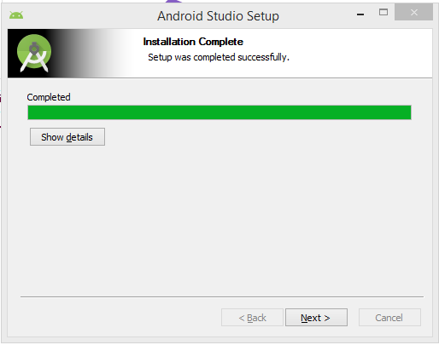

Step-7:

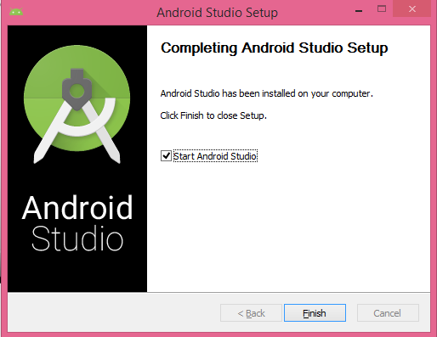

Step-8:

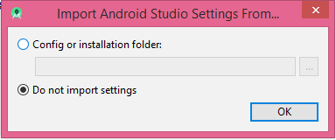

B- Enable Virtualization Support (for Intel Processors):

In order to enable the virtualization support for intel processors, just restart the PC. Press F2 for Boot Menu and search for virtualization support and enable the VT-X support.

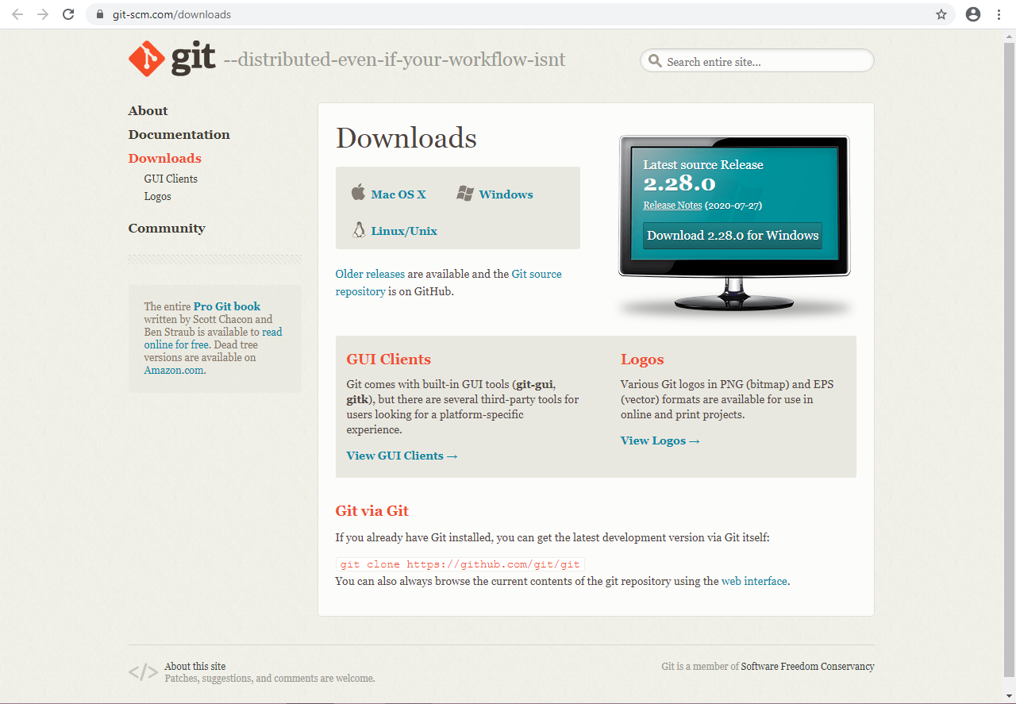

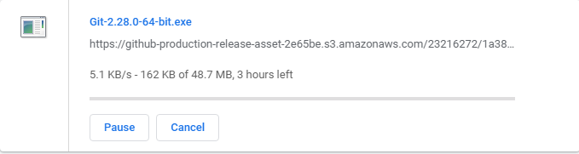

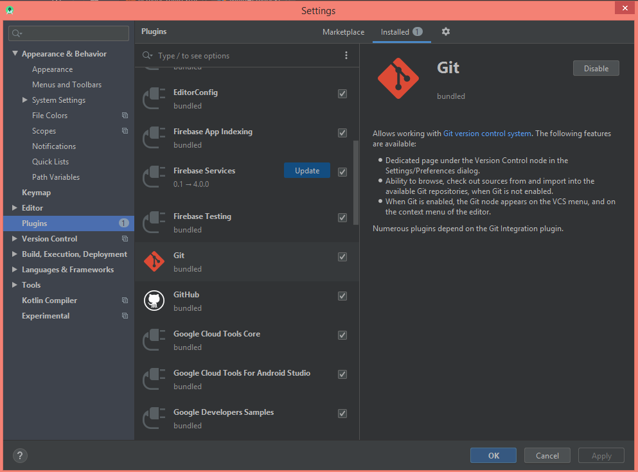

How to Start Android Studio:

After installing the Android Studio successfully for the first time, then double click on the android studio icon or go to the search option and search for Android Studio and hit enter to start the Android Studio.

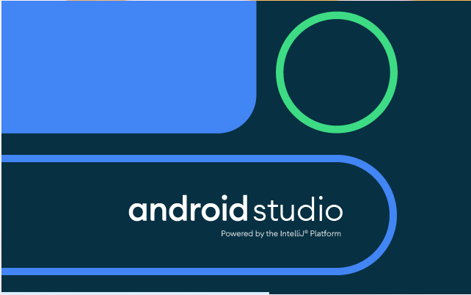

Welcome Window:

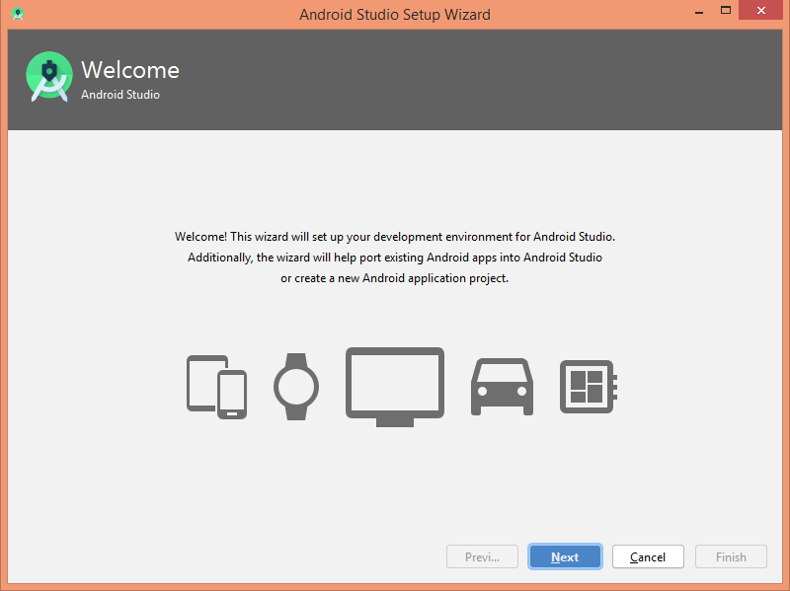

Install Type:

Recommended: The settings organized and modified by the Android Studio developers and makers for every beginner.

Custom: If someone want to change the settings of Android Studio then he/she should select the custom for their own preferences.

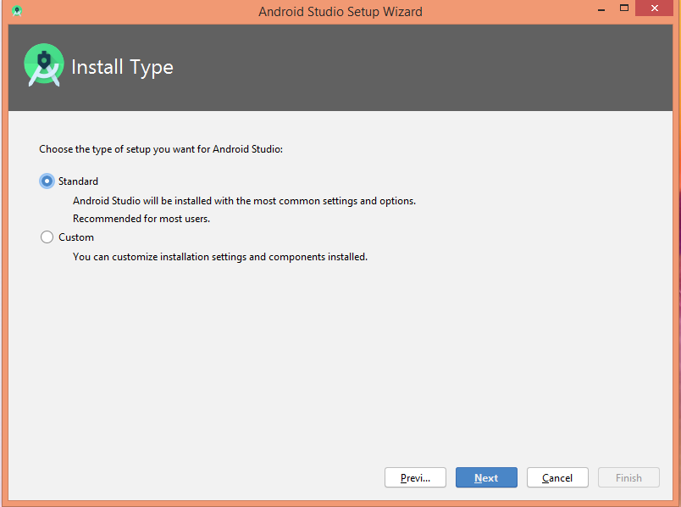

Themes Windows:

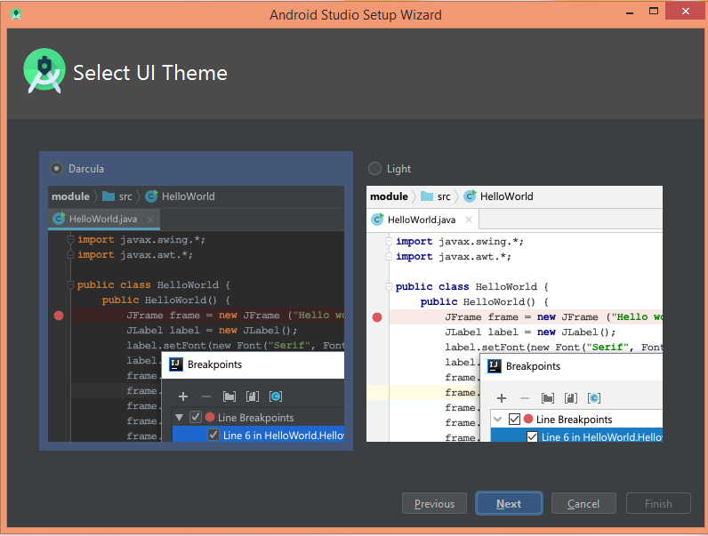

Additional supportive software:

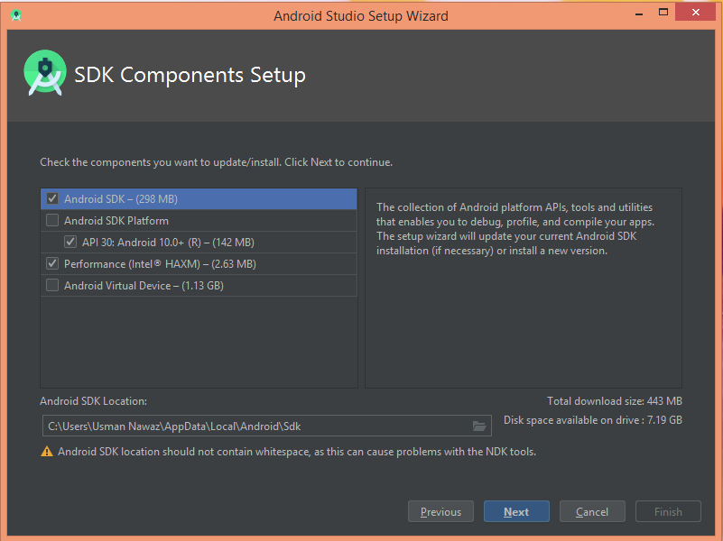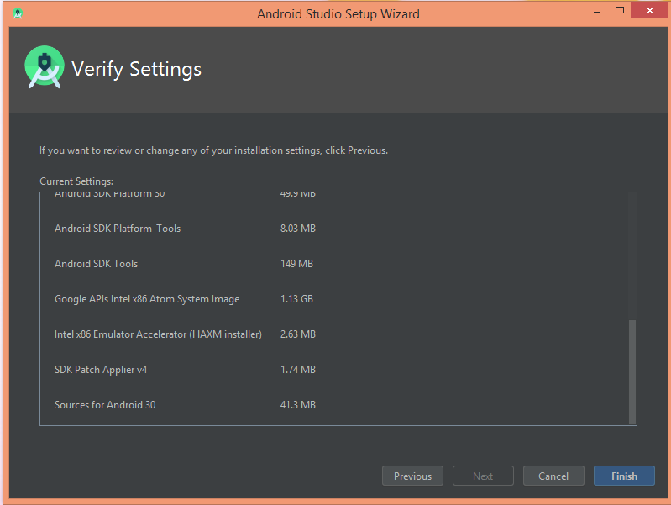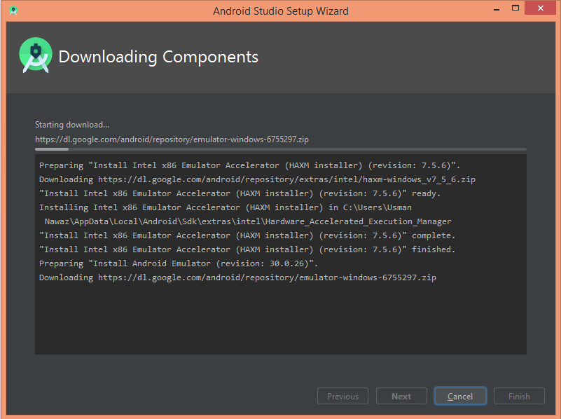

This is the first page after settings all the things in android studio. After setting everything, user will get this type of screen (screen may different depending upon version).

Starting new Project (Hello World App):

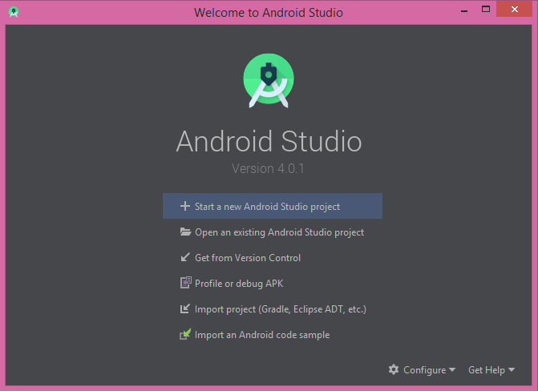

Select Empty Activity:

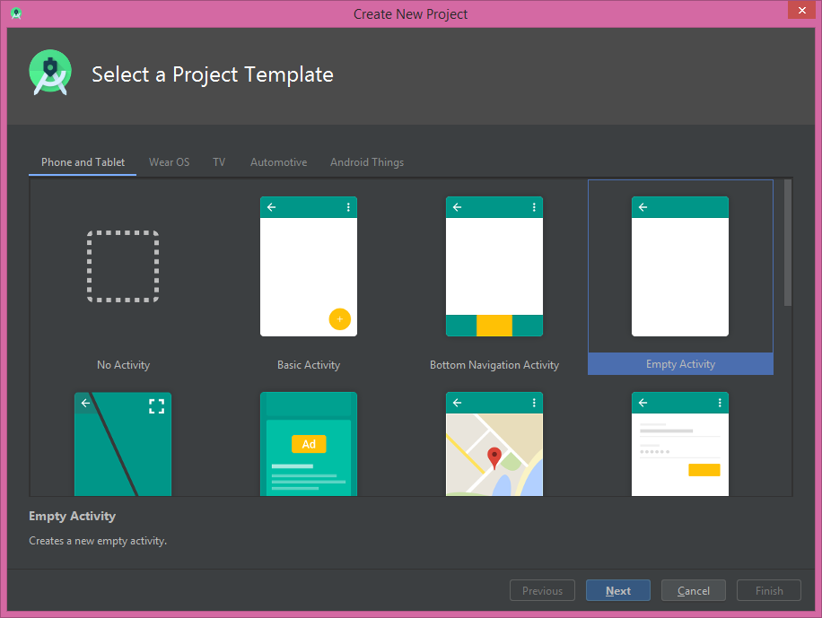

This is the basic and simplest view of the newly project which is gonna be created in the Android Studio.

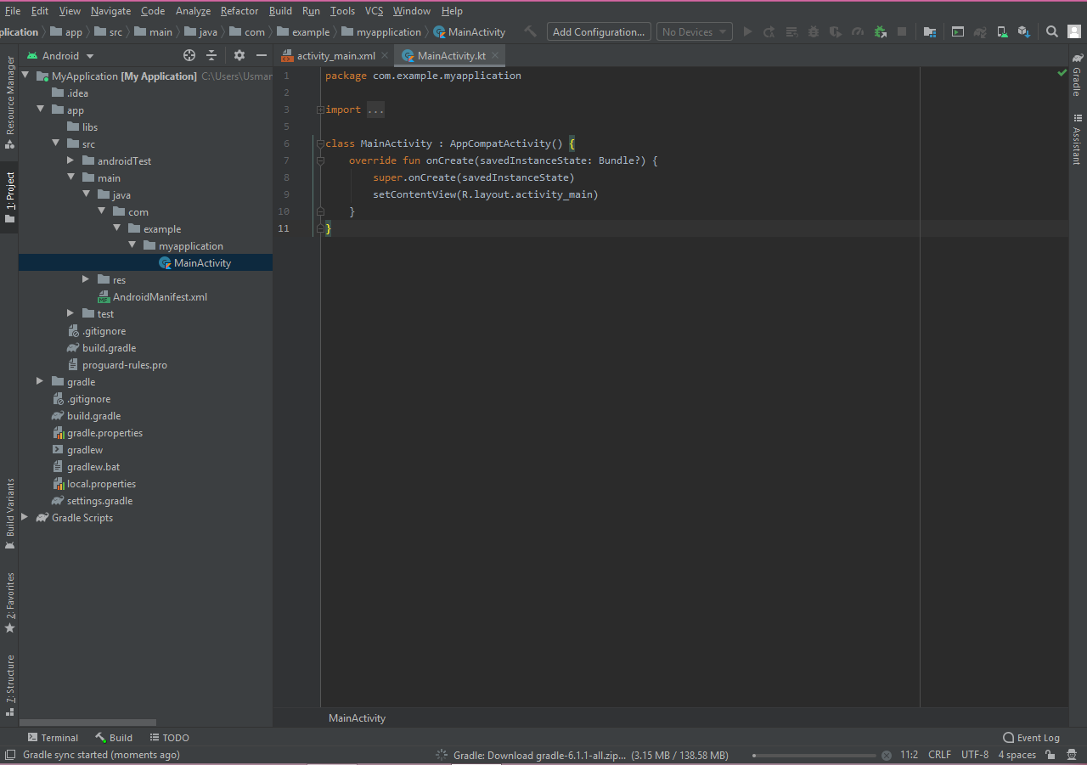

Creating Emulators (Android Virtual Devices - AVDs):

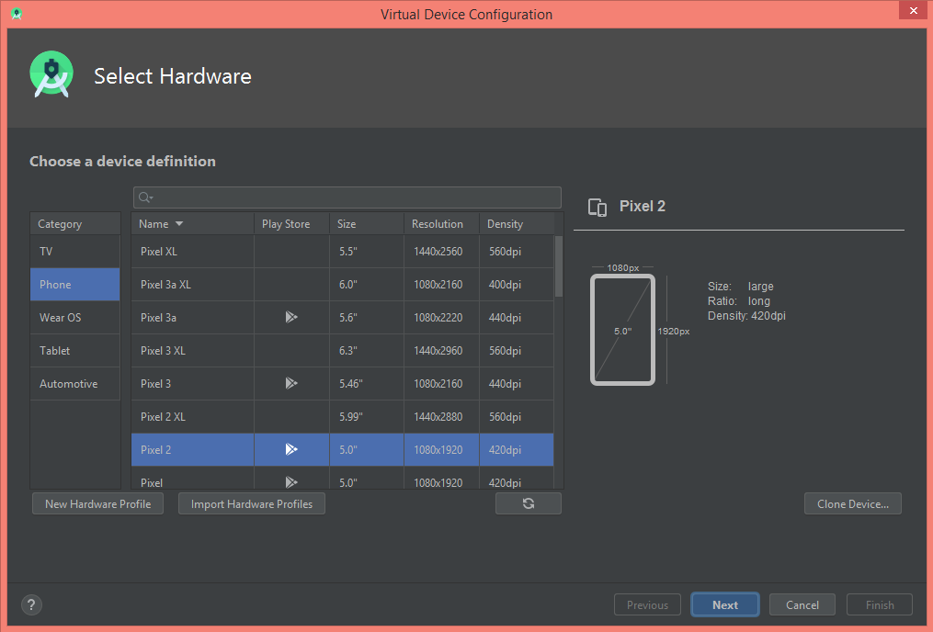

For the first emulator we are goona use the API 25 which Naugout an android flavour.

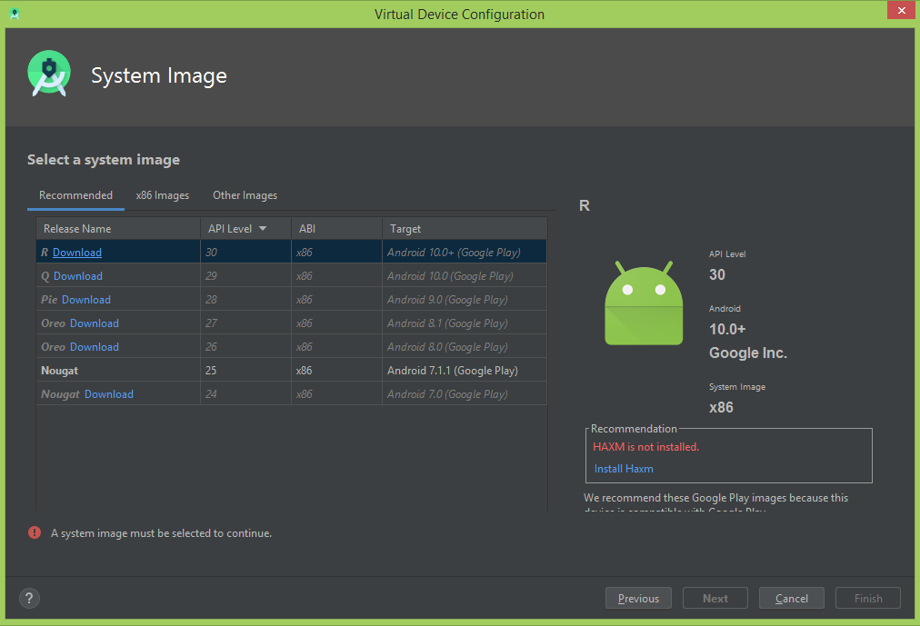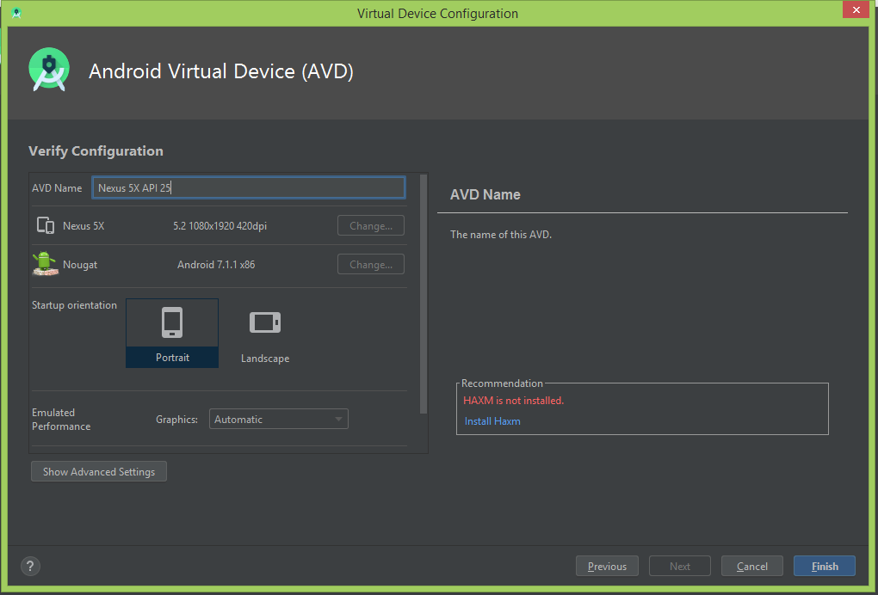

For second emulator we use the another device that is Nexus 4 and we will use the API 22 that is Lollipop another android flavour.

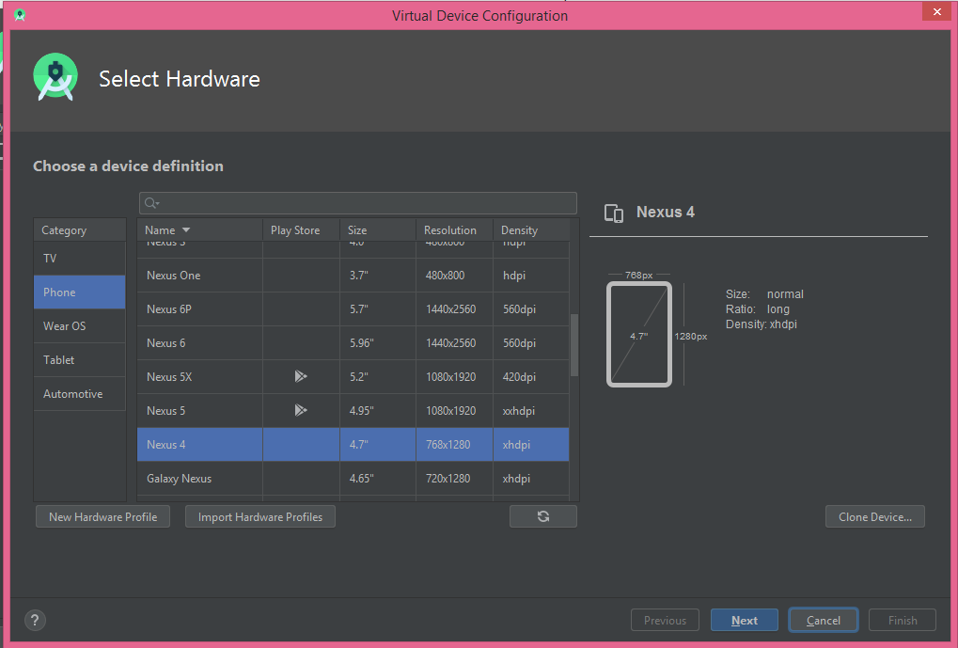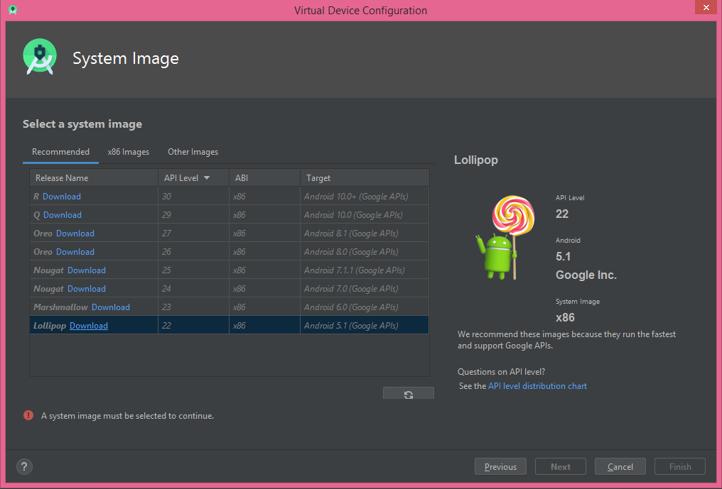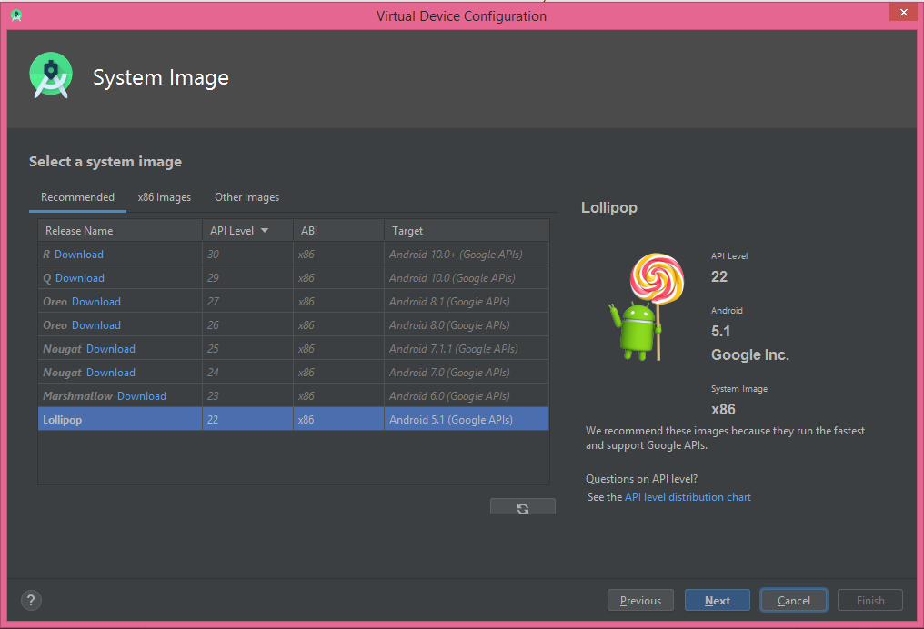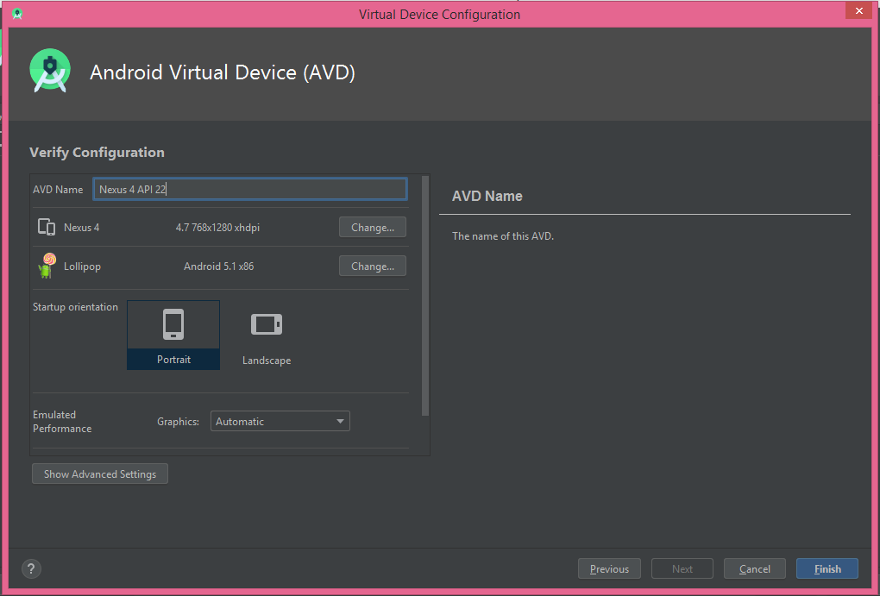

Main Activity:

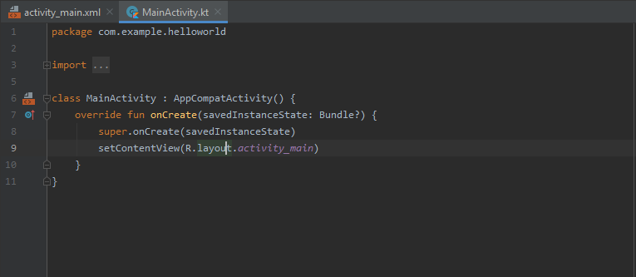

Activity Layout in XML:

Adding Button and textview in the layout just the drag and drop from left to the right.

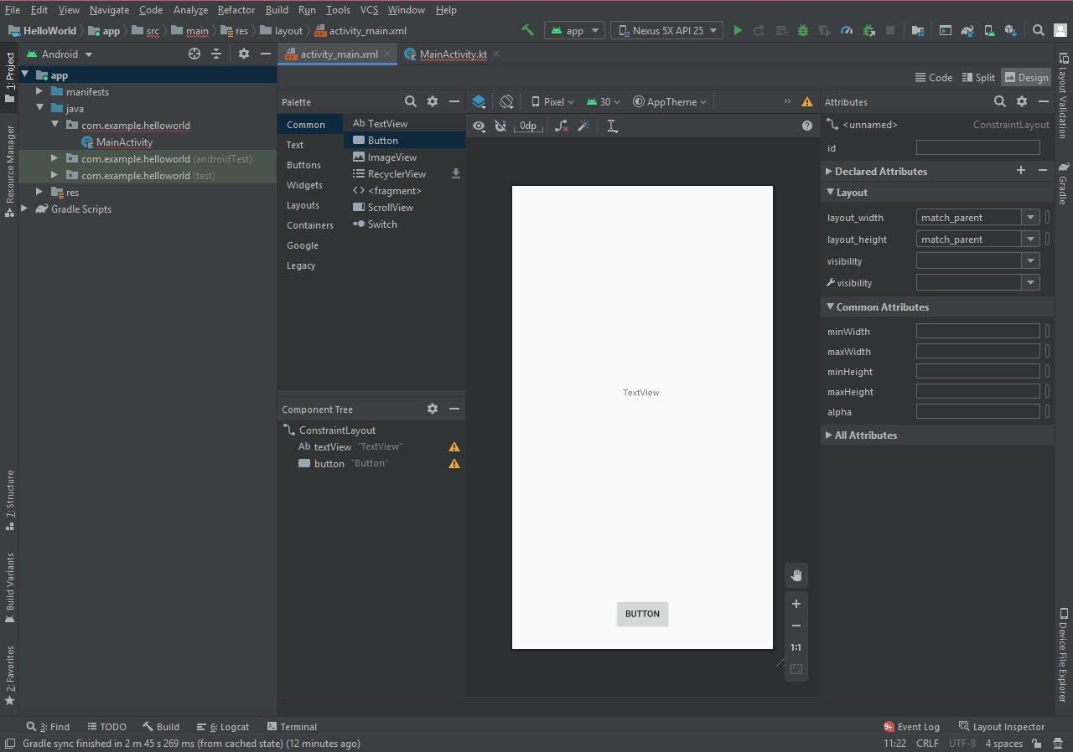

Background coding of changing the text in the textview area by clicking on the button.

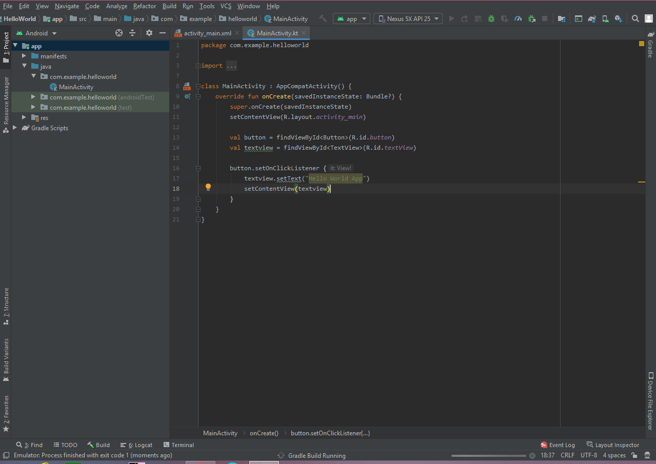

Adding another button which will change the colour of textview.

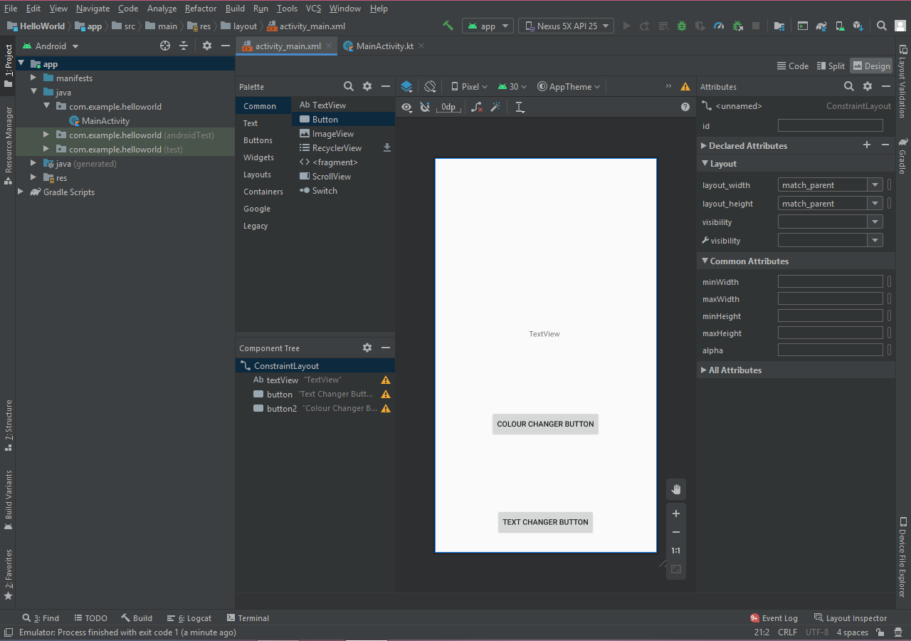

Coding of changing the colour of textview by clicking the colour changing button.

